# **Tip the Trip - Final Report**

# **Paulami Ray || Kumkum Yadav || Akhila Khanapuri**

**Background:** NYCTaxi and Limousine Commission has Green / Boro-taxi services that can only pick up passengers from the streets in northern Manhattan (North West 110thStreet and East 96th Street), and anywhere else in the 4 boroughs (except the airport area). They can drop passengers anywhere including the airport areas in the 5 boroughs.

**Problem Statement:** The amount of tip reflects the customer satisfaction/dissatisfaction of the taxi rides. This analysis could be used by the NYC TLC to get an idea on how to improve the taxi service so that it does not get replaced with the Uber/Lyft services. The amount of tip depends on various factors like trip duration, payment type, speed, time of the day and distance travelled among others. We predicted the accuracy of expressing tip as a percentage of total fare amount in the taxi rides.

**Tools/Libraries:** We have primarily used Python for this project and used different python libraries like pandas, numpy, datetime to process and wrangle the data, matplotlib to visualize the data and scikit-learn libraries for implementing machine learning algorithms.

**Dataset:** The“Trip Sheet Data” dataset has been taken from the NYC.gov website for the month of June 2018.There were initially 739373 observations and 19 features. Fig 1 shows the size of the data set after loading it in Python.

*Url****:*** [***http://www.nyc.gov/html/tlc/html/about/trip_record_data.shtml***](http://www.nyc.gov/html/tlc/html/about/trip_record_data.shtml)



**Fig 1: Size of the Dataset**

**Feature Description:** The following are the features that are present in the initial dataset:

* **VendorID:** Indicates the LPEP provider, 1= Creative Mobile Technologies, 2= VeriFone Inc.
* **lpep_pickup_datetime:** The date and time when the meter was engaged.
* **lpep_dropoff_datetime:** The date and time when the meter was disengaged.
* **Passenger_count:** The number of passengers in the vehicle. This is a driver-entered value.
* **store_and_fwd_flag:** Indicates whether trip was recorded before sending to the vendor.
* **RatecodeID**: The final rate code at the end of the trip.
* **PULocationID**: TLC Taxi Zone in which the taximeter was engaged.
* **DOLocationID**: TLC Taxi Zone in which the taximeter was disengaged
* **trip_distance**: The elapsed trip distance in miles reported by the taximeter.
* **fare_amount**: The time-and-distance fare calculated by the meter.
* **Extra**: Miscellaneous extras and surcharges.
* **MTA_tax**: $0.50 MTA tax that is automatically triggered based on the metered rate in use.
* **Improvement_surcharge**: $0.30 improvement surcharge assessed on hailed trips at flag drop
* **Tip_amount:** This field is automatically populated for credit card tips. Cash tips not included.
* **Tolls_amount:** Total amount of all tolls paid in trip.
* **Total_amount**: The total amount charged to passengers. Does not include cash tips.
* **Trip_type**: Indicates whether the trip was a street-hail or a dispatch.

The below Fig 2. shows the data types of the different variables as loaded programmatically.



**Fig 2: Data types**

**Data Preprocessing & Cleaning:**

Although the data set did not have many missing values, the data set was very dirty. The sources for this uncleaned data are unrealistic fares, negative trip distances, same pickup and drop off locations, incorrect location ids etc. So, as part of the data cleaning and pre-processing we did the following steps:

* Negative values in columns *Total_amount, Fare_amount,Improvement_surcharge,Tip_amount,Tolls_amount and MTA_tax* were replaced by their absolute values.
* Negative distances were changed to their absolute values.
* Invalid values in *RateCodeID* were replaced by most frequent value 2.
* Invalid values in *Extra* were replaced by most frequent 0.
* Fares less than $ 2.5 in *Total_amount* were replaced by the minimum fare of taxis which is 2.5.
* Timestamp variables were converted to ‘YYYY-MM-DD H:M:S’ format
* *Ehail_fee* had maximum NULL values so it was dropped.
* Encoded the categorical variable *store_and_fwd_flag* to numeric.
* Deleted the trips which had same pickup and drop off locations.

**Feature Engineering:**

As part of the feature engineering process we created some new variables that would be used in further exploration as well as our prediction model.

**Time variables:**

* Week: shows the week in the month of June
* Week_day: shows the day of the week
* Month_day: shows the day of the month
* Hour: shows the hour of the day
* Pickup_hour: shows the hour of the pickup for the ride
* Trip_duration: shows the overall trip duration derived from the pickup and drop-off date time.

**Speed:**

* Speed_mph: derived it as the ratio of *Trip_distance* to *Trip_duration.*

**Tip:**

* Tip_percentage: expressed the tip as the percentage of *Tip_amount* and *Total_amount* 100*data.Tip_amount/data.Total_amount
* With_tip: expressed it as 1 where the transaction is tipped and 0 where it has not.

**Latitude/Longitude:** The Taxi Zone Shapefile was downloaded alongside dataset and was used to convert to coordinate system. This newly generated .csv file was then merged with the main dataset based on the Pickup LocationID and Dropoff LocationID.

* PULatitude: show the Latitude coordinated of Pickup LocationID.
* PULongitude: show the Longitude coordinated of Pickup LocationID.
* DOLatitude: show the Latitude coordinated of Dropoff LocationID.
* DOLongitude: show the Longitude coordinated of Dropoff LocationID.

**Exploratory Data Analysis:**

We began our analysis by exploring the data set first. Since the data set contains different trip data of the green taxis we wanted to understand how most of the trip distance are distributed over the month and is there any hour specifications when the trip distribution of the trip is high. This led to the following two plots.

* **Trip Distance Distribution:**

We programmatically plotted the histogram of the trip distance in miles with the number of occurrences (i.e. count) of the trip distances.



**Fig 3(a): Histogram of trip distribution with outliers**



**Fig 3(b): Histogram of trip distribution without the outliers**

The distribution is highly right skewed where the median is smaller than the mean. The skewness could be attributed to the fact that the variable has a lower boundary of 0. This means that as the trip distance increased the number of occurrences of those trips decreased considerably. That is, long trips occurred less frequently than short trips. We initially tried to plot the histogram on a raw data set keeping the bin size as 30. The plot had outliers as shown in the below Fig 3(a). If the data point is three standard deviations away from the mean, then it is termed as an outlier. Then, we again plotted the same histogram discarding the data points (outliers) that lied beyond three standard deviations from the mean and then applied the log normal distribution fit to achieve the desired plot as shown in Fig 3(b).

**Insight**: The trips were not random in nature and were driven by a common factor. Although the green taxis are not allowed to pick up passengers inside the densely populated areas of Manhattan they are allowed to drop the passengers. The trip distribution indicates that people travelled for shorter distances most frequently which could be for a definite day to day purpose like going to work place.

* **Hourly distribution of the trips:**

Next, we wanted to check if hour of the day has any impact on the distribution of the trip. The below plots, Fig 4 & 5 shows the mean and the median distances across the day respectively.

**Insight**: It can be observed that during the morning hours the number of trips increased, especially starting from 5 AM to 7 AM.



**Fig 4: Mean Trip Distance across the day**



**Fig 5: Median Trip Distance across the day**

We observe longer trips mostly in the first hours of the day which we think is due to the fact that people are hiring taxis to commute to work when there is much rush in the public transportations. The trip distances are also less and more frequent which hint towards this hypothesis. Also, most of the people are racing against time while they go to work in the morning and to lessen the travel time they are hiring the taxis. The taxi travel count is much less in the evening hours because people mostly prefer to travel back by public transports as they are not in a hurry as in the morning. The mean and the median graph distribution helps us to derive this hypothesis.



**Fig 6: Table for Mean - Median Trip Distance across the different hours of the day**

* **Top ten Pickup and Drop-off locations:**

Now that we know the typical busy hours of the day, we checked the top ten pick up and drop off locations for the taxis based on the location id given in the graph. Fig 7 and Fig 8 provide a map visualization of the dispersion of pick-up locations and drop-off location across the five boroughs.

Fig 9 and 10 shows the top ten pick-up and drop-off locations.

**Insight**: The top ten locations did not include any of the important airports of the region – Newark, JFK or La-Guardia. The most popular pickup and drop-off locations was East Harlem North which lies in the neighborhood of Upper Manhattan. This result was a little surprising to us as not many offices or tourist attractions are present in this area and in fact, it is known for vibrant environment and good music. We wondered here, perhaps people might be travelling to this area just to have a good time enjoying and relaxing.

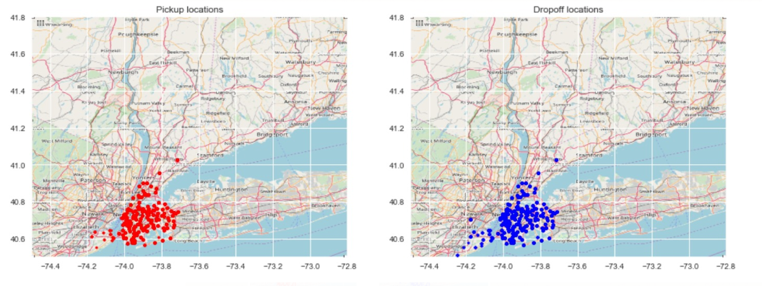

**Fig 7: The geographical visualization of Pickup and Dropoff Location (zoomed out)**

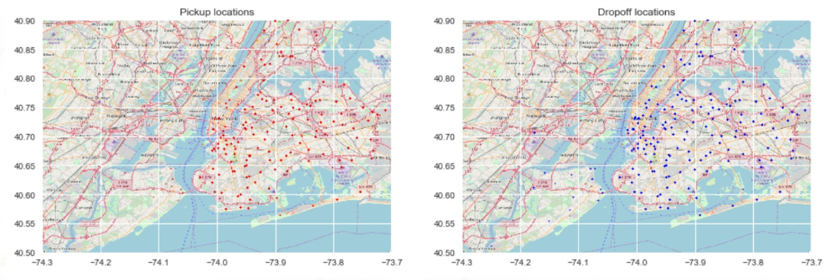

**Fig 8: The geographical visualization of Pickup and Dropoff Location (zoomed in)**



**Fig 9: Top Pick Up Locations**



**Fig 10: Top Drop Off Locations**

* **Airport Trips:**

The two major airports in NYC is John F Kennedy (JFK) and Newark (NEW). Based on the RateCodeID mentioned in the data dictionary of the NYC website, we concatenated the data for RateCodeID = 2 in case of JFK and 3 in case of NEW and marked them as the airport trips. The rest were marked as non-airport trips.

* **Airport Trip Distribution:**

When we checked the total number of trips to and from the NYC airports and found that the number was quite few and this validated our output in the top pick up and drop off locations.







**Fig 11: Trip Distribution by trip type**

**Insight**: The histogram in Fig 11 shows two peaks for the airport travels, both the peaks being 15 miles or more in distance. The peaks indicate that people from neighboring areas or suburbs mostly travel to the airport in the green taxis. This is interesting to note, that although the longer trips in the green taxis are less in number but almost half of the long trips are to and from the NYC airport. The non-airport trips are peaked at a distance lesser than 5 miles.

* **Hourly Trip Distribution:**



**Fig 12: Hourly Trip Distribution by trip type**

**Insight:** We have plotted the hourly distribution of the trips. The blue line indicates the airport trips and the red line indicates the non-airport trips. The airport trip seems to peak at 15:00 hours that is around 3 pm in the afternoon which means people who were travelling to catch the early evening flights rode the green taxis most. Also, there seems to be no ridership to the airport in the late night that is around 1 am or 2 am in the taxis. On the contrary, for the non-airport trips, the peak hour seemed to be after 8 pm, with moderate peaks around 3 pm. So, the ridership depends on the destination choice of the passengers and it is relative to the hours of the day they are travelling.

* **Tip Distribution:**

We checked the tip distribution of the transactions that were made. From the below histogram, Fig 13 we can clearly see that less than 40 % of the transactions are tipped and rest has no tips given which led to my classification model to distinguish between two types of transactions.

The Fig 14 shows the peaked percentage of tips which is around 13%.



**Fig 13: Distribution of Tip for all transactions**



**Fig 14: Percentage Distribution of Tipped transactions**

* **Correlation Heatmap:**

We plotted the correlation heat map to find out which independent variables had a correlation among each other. The continuous variables were *'Total_amount','Fare_amount','Trip_distance','Trip_duration','Tolls_amount','Speed_mph','Tip_percentage'*. The heatmap is shown in Fig 15.

**Insight:** There seems to be no linear relationship between the other variables and Tip percentage.



**Fig 15: Correlation Heat Map**

**Model Selection:**

**Objective**: We built a predictive model for tip as a percentage of the total fare.

**Building the Model:** We have tried to build the predictive model on top of the *Decision Tree* and *Gradient Boosting* classification algorithm and *Random Forest* regression algorithm as there were no linear relationship between the dependent and independent variables. Finally, we have combined the classification and regression model to predict the final tip percentages that would be expected.

In majority of the transactions which had tips associated with it were paid by credit cards. So, we decided to make a classification model to distinguish the transactions with tips and without tips. 40% of the transaction were tipped. Fig 16 shows the feature importance in the classification model and it shows that *trip_duration, total_amount and payment_type* are important predictor variables.

The prediction was done mainly in three steps 1) using a classifier to determine whether the transaction will pay a tip and 2) using a regression model to determine the percentage of the tip if the transaction is classified under tipped and 3) final model combining both the models to find the accuracy.

1. **Classification Model**: The classification model was built on gradient boosting algorithm. We worked with decisions trees first in which the accuracy came around 90.6%. But as gradient boosting gave a much better performance accuracy we selected it for our final model.

**Step 1**: Created several functions like ‘modelfit’ which will train models and perform cross validation and optimize_num_trees which will optimize estimators through grid search and further tune the parameters.

**Step 2:** We have chosen the training sample size as 100000 and have optimized just the number of trees in this case as it was the primary factor to boost the model accuracy. We have kept the subsample size less than 1 to increase the bias and decrease the variance as we know a little bit of bias is acceptable compared to increased variance.

**Step 3:** As the model validation metric, we have used ROC-AUC (Area under the curve of receiver operating characteristic) as it best determines classification binary outcomes.

**Step 4:** Initiated the classification model and then saved the best estimator on disk for future use using the pickle feature in python.



**Fig 16: Feature Importance in Classification Model**

The training model accuracy is shown below:



On running the classification model on the validation test set the below ROC AUC has been reported:

**ROC AUC: 0.958299115234**

We know that the score of the feature_importances attribute in gradient boosting classifier is highest for the most important attribute among the predictors. The features are always randomly permuted at each split. The n_estimators gives the number of boosting stages. The optimum number of trees as per the output is 150. Gradient Boosting is fairly robust to over-fitting therefore, a high number of the estimator gives a better performance.

1. **Regression Model:** We used Random Forest as our algorithm for the regression model

**Step 1:** Similar to the classification model, we have kept the sample size as 100000 for the training data with 5-fold cross validation.

**Step 2:** For boosting the modelaccuracy, we have optimized the number of trees.

**Step 3:** As the model validation metric, we have used mean squared error in this model.



**Fig 17: Feature Importance in Regression Model**



We preferred to use random forest algorithm due to its precision and optimization facilities over others. It solves the over fitting problem in the decision trees. The main advantage of using Random forest in this case is that it includes multiple decision trees and the average of each tree outcome would become the final outcome of the algorithm. The mean squared error on the test sample came to around 3.05. In this case the optimum number of trees are 150. As seen in the histogram in Fig 17, the most important features are *payment_type* and *total_amount* among the predictors.

1. **Final Best Estimator** **Model:** The final model works as the combination of the classification and regression model to predict the expected tip percentages in the green taxi rides.

**Step 1:** We defineda function predict_tip to predict the tip of the transaction if at all it is tipped from the outcome of the classification algorithm.

**Step 2:** Weran the prediction on thesampled data to determine the mean squared error value and R squared value.





**Fig 18: Residual Plot for the final model**

We also plotted the residuals as in Fig 18 which is symmetric in nature which indicates that the model is equally biased.

We know that the R-squared value intuitively gives the measure of how close the data is to the regression fit line. Therefore, higher the R-squared value, better the model fits our data. In this case with our final model, the score comes around 0.8948 which is pretty good considering this scenario.

**Future Work:**

* Thorough analysis within the clusters of the rides within inter and intra cities of Manhattan with the help of heat maps.
* Using other bagging and boosting techniques to see if that improves the model performance.
* Could also check if the ridership depends on the season of travel i.e., particular months or holiday months (thanksgiving week, Christmas etc.) where people are in a good mood so there could be a possibility to pay a tip compared to regular days.
* Validate the predictive model through various test statistic methods.

**Team Contributions**

We distributed the work among ourselves and then collaborated to come to some common conclusions and draw insights. Since this NYC data set is a public one, many people have used it to draw different insights and visualize them. We have used the latest data set available on the website – Jun 2018 and tried to derive our way of insights and prediction on it. Broadly classified, these are some of the sections we worked individually, and then discussed together:

**Paulami** – Exploratory Analysis and Model Selection

**Akhila** – Exploratory Analysis related to visualizing the latitude longitude of the top locations

**Kumkum** – Data Preprocessing and Cleaning

**References**

* [http://www.nyc.gov/html/tlc/html/about/trip_record_data.shtml](https://towardsdatascience.com/understanding-auc-roc-curve-68b2303cc9c5)
* <http://www.nyc.gov/html/tlc/downloads/pdf/data_dictionary_trip_records_green.pdf>
* <https://towardsdatascience.com/understanding-auc-roc-curve-68b2303cc9c5>
* <https://nycdatascience.com/blog/student-works/nyc-taxi-riders-tipping-behavior-analysis/>